**SOLITAIRE TO DO LIST**

SOLITAIRE CASE STUDY

<https://john.cs.olemiss.edu/~hcc/csci581oo/notes/budd09.html>

*Got the classes and explanations from this file of a CS class.*

Kelly

TEXTURES CARPET (Start Date: 3/21/22) - (Due: 3/23/22)

-Get all the images for the cards and backgrounds. Could also include textures for the buttons.

THINGS TO CODE

Brook

Card Class (Start Date: 3/24/22) - (Due: 3/29/22)

-The dimensions of the card, how it looks both on the front and the back.

-Suit (clubs, diamonds, spades or hearts) and Rank (K, Q, J, 10, etc.)

Brook

Cardpile Class (Start Date: 3/29/22) - (Due: 4/4/22)

-Virtual representation of the full deck of 64 cards.

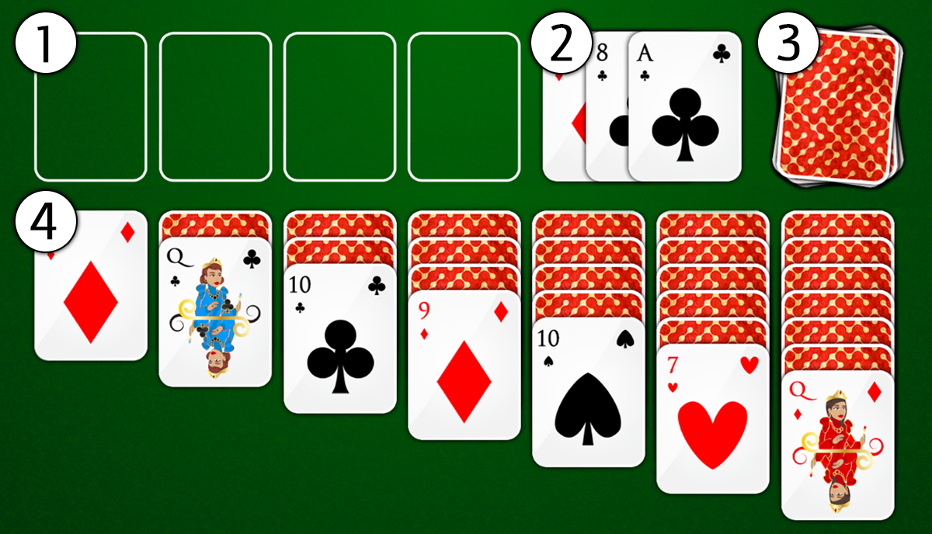

Ana

SuitPile [1] (Start Date: 4/4/22) - (Due: 4/8/22)

-4 piles for the pile of suits

-Takes their respective cards and denies any other type of card (incorrect suit or incorrect rank)

Zamzam

Discard Pile [2] (Start Date: 4/4/22) - (Due: 4/8/22)

-Cards are face up on the discard pile.

[Preview with face-up cards.]

Zamzam

Deck pile Class [3] (Start Date: 4/8/22) - (Due: 4/12/22)

-Shuffles cards.

-Cards are face down.

Ana

TablePile [4] (Start Date: 4/8/22) - (Due: 4/12/22)

- 7 decks of cards to construct.

Kelly

Solitaire Game Class (Start Date: 4/12/22) - (Due: 4/17/22)

-Creates an instance of the game.

-Creates a window, initializes the game and displays it.

Ana

Solitaire Frame (Start Date: 4/12/22) - (Due: 4/17/22)

- GUI Window

- Has listeners for clicks

- Deals with the user interaction with buttons and cards.

-Takes care of the game itself and the gameplay.